Project Title: Exploring the Effect of Teaching Music on Imitation and Joint Attention skills of Children with Autism through a Xylophone Player Humanoid Robot

Principal Investigator: Dr. Mohammad Mahoor
DU IRB Protocol #: 7428820-1
Version Date: June 25th 2015

- Background: (this section needs to be a full page long and it all needs to be the same font. And size.

Music has a great influence on children’s emotions and feelings. It causes appearing or improving social, verbal and non-verbal communication skills in children. Melody and rhythm could promote happiness, exhilaration, as well as motor coordination and ability between different tasks. The results of different music therapies for children with autism encourage clinicians to promote the use of embodied music-based approaches to facilitate multisystem development. Psychologists believe that music therapies promote communication, social-emotional, perceptuo-motor, and behavioral skills in children with autism spectrum disorders [1]. Although music therapy researches have been studied by some physiologists on autistic children in individual and group intervention sessions [1], to our knowledge, using a humanoid robot in teaching music to ASDs has not been reported. Individuals with autism, contrary to their inability to understand and participate in social events, will enjoy interacting with computers, intelligent toys, and robots. In recent years, the usage of robots in autism diagnosis and treatment has been increasing [2-6]. Researches focusing on applying robots in autism treatment have pointed out that robots increase enthusiasm, focus, and attention; and cause novel social behaviors such as joint attention and automatic imitation. Researches also indicate that autistic children work quite naturally with robotic technologies [2, 5].

Thesis: The main purpose of this study is using a drum and xylophone player humanoid robot in teaching music to children with autism. Through a designed music therapeutic scenarios’ package, we want to explore the music intervention sessions effect on ASD’s improvement in imitation, joint attention, cognitive, social, and communication skills. We also want to engage the parents in some of the music games and explore the improvement of children with autism in turn-taking skill and measure any behaviors from the child directed to the parent in Robot-Child-Parent triadic interactions.

- Design
Study Population:
  - Children that have been diagnosed with Autism Spectrum Disorder between the ages of 4 and 17.
  - For the Control group: children that are typically functioning between the ages of 4 and 17 will be recruited.
  - For the control group, children that are siblings to children that are diagnosed with ASD will be excluded.
.
- Recruitment and Consent:
Participants will be recruited through out Denver CO and surrounding cities. Recruitment will begin during the end of July and will end when the desired amount of participants have been recruited. 20 Participants (10 high functioning- and 10 low-functioning autistic children) will be recruited through advertisement such as flyers through postings in hospitals, schools and clinicians offices.
Consent will be received from both the parent and child before the study begins. In which case the participant and guardian will receive full detail of what the study entails and what the child will be doing in each session. Consent will be taken by a trained research assistant who will verbally go over the consent form before participants sign the documents. Consent and any other identifying information will be stored in a locked secure cabinet. All participants will be coded by number to ensure confidentially.

Procedures:
Time Commitment
The time commitment for each participant will be 8 to 12 sessions over the course of eight to sixteen weeks. Each session will consist of two parts with rest periods in between. In total each session will be approximately an hour and a half including set up and rest periods.

Study Procedures, Assessment and Subject Activities
The activities in each of the sessions in this study are shown in Table.1. A description of each activity follows. Except for the human baseline, all activities will be given by the robot and/or the human therapist. It should be noted that we also need the parent to attend the games room. The parent will be engaged in turn-taking modes of the music games.

Session one: Baseline

Table1. Music-Therapy Intervention Sessions’ Schedule
Session No. | Outline | Intervention Description | Purposes
2 | -Strike xylophone’s bars using mallet, without considering bar colors | 1-No bars were removed from the xylophone. The child should hit an arbitrary bar after each robot’s struck.  2-Some of the bars will be removed. Repeat Step 1 with less bars on xylophone.  3-Repeat Step 1, while the child should use both of his/her hands in order.  4- Repeat Step 2, while child should use both of his/her hands in order.
2 | -Considering bar’s Color  -Match the colors | 1-Review of the previous tasks (Steps 3 and 4)  2-Imitation of child from the robot’s tasks considering the bar’s color (Preferably main colors include Red, Blue and Yellow )  3-The robot strikes a bar and the child point to the same color on the board.  4- Eyes’ color of the robot change and the child have to hit on the same color on the xylophone. | -Colors Recognition  -Improve in Joint Attention skills
3 | -Hitting bars while counting | 1-Review one-hit imitation task considering bars’ color.  2- Imitation from the robot hits considering the number of struck notes (one or two). Child should count “one-two” while hitting the bars.  3- Imitation from the robot’s hits while saying Baam-Baam. | -Improve Verbal short-term Memory  -Improve the perception of numbers and counting
3 | -Hitting bars without counting | 1-Review previous session’s tasks  2- Imitation from the robot’s hits without counting. | -Improve auditory discrimination
4 | -Rhythm Perception | -Review previous tasks  -Imitation from the robot while striking 3 or 4 notes in order considering the time interval between each notes. We can do this task using a drum as well as a xylophone. | -Improve auditory imitation skill  - Good cooperation between eye and hands movements  - Improve the Visual pursuit
4 | -Playing a virtual xylophone on the screen and move to turn-taking games | 1-Review the rhythm perception  2-The therapist/parent hits some virtual xylophone’s bars on the screen/wall and expects the child and the robot to imitate him/her on real xylophone. | -Sharing attention between different tasks  - Improve in playing turn-taking and group games in robot-child and robot-child-therapist/parent interactions
5 | - | 1-Review the rhythm perception  2-The robot shows/says two or more colors to child and he/she have to hit xylophone bars with the same color. | -Working memory of children with autism, Dual task performance  - Improve in joint attention skill
5 | -Teaching the notes | 1-Review the rhythm perception  2-Notes A to G will be written on cards with their related colors on the instrument. The therapist/parent shows each card to child and he/she have to repeat the name of the note and strikes the same note on xylophone. | - Improve in shifting attention skill  - Improve in auditory memory of children
6- 7/11 | -Sight reading in music | - Review the note names  -The child has to say each note’s name while he/she hits on the bars.  - Playing a short phrases of notes by the child and the robot assesses his/her performance. | -Improve the cooperation between behavior and motor skills of child
6- 7/11 | -Change the instrument to Piano | -Review previous tasks  -Expect the child to generalize his/her learned materials on the piano and virtual xylophone | - Create generalization skills

Session 8/12: Human Assessment

Protocol Prompt Design
The simple flowchart of the designed Robot-Child scenarios for our robot-assisted intervention sessions is illustrated in Fig.1.
Protocol Prompt Design
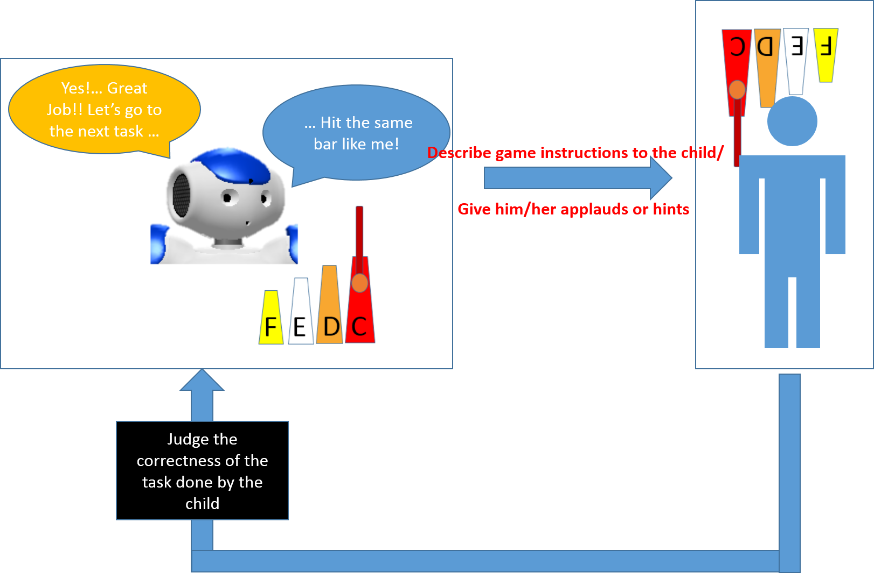
Figure 1. The Flowchart of the Robot-Child interactions

Baseline: The baseline will serve as means for measuring the child’s progress through the intervention. It will be carried out in a similar way as the intervention described above except without any feedback from the therapist.
Interaction Test: This is the same as the baseline except conducted at the end of the final session to gauge the improvement of the child.

Measures:
During each session Robot-Child-Therapist/Parent interactions will be recorded with 5 HD cameras and four surveillance cameras. The child’s responses to each activity and the reward given by the robot/therapist will also be recorded to keep track of improvement of the child. A Microsoft Kinect camera will also be used to record the child’s and the therapist’s body poses and relative positions. In addition a Q-Sensor from Affectiva will be used to record electro dermal activity on the child with a sensor on each wrist worn as a watch. The Q-Sensor data provides a means of keeping track of valence of emotions the child may experience during the sessions. Recording of these data is mandatory for participation.

- Risks:
We anticipate no more than a minimal risk in participating in this study. During the course of the study, children are likely engaged in interactions. We anticipate that some children may feel shy and do not want to interact with the research assistant. Sessions will be discontinued if the child or the parent feels the child is not comfortable. Breach of confidentiality is the only known risk that is associated with this research. In order to minimize this risk, all identifying information will be stored in a locked cabinet within the school. Each participant will be coded by number to ensure confidentially and to minimize risk to the participant. Data collection will remain completely anonymous and the topic is not sensitive. If the child or parent feels uncomfortable at any time during the study, sessions will be stopped immediately.

- Benefits to subject or future benefits
This study is designed for the researcher to learn more about improving imitation, joint attention, and social skills of children with autism spectrum disorders. The following benefits may be associated with the child’s participation in this study: As a result of the study, the imitation and joint attention skills of the child may be increased and he/she may learn skills to show eye gaze attention

- Confidentiality:
To keep information safe, the researchers will make sure child audio and video records will identified by code number only and will be kept separate from information that could identify them. This is done to protect the confidentiality of the child’s responses. Only the researcher will have access to the child’s individual data and any reports generated as a result of this study will use only group averages and paraphrased wording. The data and records that the child provides will be stored in a locked location only to be seen by researchers. The data and records are stored in the research lab in a locked cabinet that has two keys. One, that Dr. Mahoor Possesses and one, that is for the research assistants. The researchers will retain the data for three years after the completion of the study. The data will not be made available to other researchers for other studies following the completion of this research study and will not contain information that could identify the child.
For coded data, the key to the code will also be stored in the locked cabinet in the research lab. This key will be destroyed at the same time all other identifying information is destroyed.
All audio, video recorded data is secured in a locked hard drive where no online access is available. All participant information in coded by number and secured.

- References:
- Srinivasan, S. M., & Bhat, A. N. (2013). A review of “music and movement” therapies for children with autism: embodied interventions for multisystem development. Frontiers in integrative neuroscience, 7.
- Scassellati, B., Admoni, H., & Mataric, M. (2012). Robots for use in autism research. Annual Review of Biomedical Engineering, 14, 275-294.
- Diehl, J. J., Schmitt, L. M., Villano, M., & Crowell, C. R. (2012). The clinical use of robots for individuals with autism spectrum disorders: A critical review. Research in autism spectrum disorders, 6(1), 249-262.
- Mavadati, S. M., Feng, H., Gutierrez, A., & Mahoor, M. H. (2014, November). Comparing the gaze responses of children with autism and typically developed individuals in human-robot interaction. In Humanoid Robots (Humanoids), 2014 14th IEEE-RAS International Conference on (pp. 1128-1133). IEEE.
- Taheri, A. R., Alemi, M., Meghdari, A., PourEtemad, H. R., & Basiri, N. M. (2014, October). Social robots as assistants for autism therapy in Iran: Research in progress. In Robotics and Mechatronics (ICRoM), 2014 Second RSI/ISM International Conference on (pp. 760-766). IEEE.
- Robins, B., Dickerson, P., Stribling, P., & Dautenhahn, K. (2004). Robot-mediated joint attention in children with autism: A case study in robot-human interaction. Interaction studies, 5(2), 161-198.

